**How to Start Tomcat Automatically At The Startup and Reboot of The Instance.**

[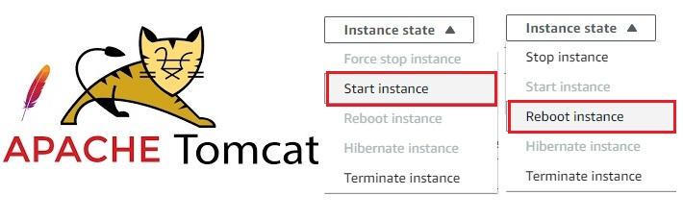](https://user-images.githubusercontent.com/119833411/241497546-e611cc72-d4ba-478e-8977-579266835886.jpg)

**Observation.**

**If you have installed Tomcat By downloading Binaryfile,Then you might have observed that Tomcat will not start after stop and start or reboot of your server.**

**Execute the following commands to Enable-Tomcat on reboot and startup of your instance.**

# Become a root user.

sudo su -

# Download java.

amazon-linux-extras install java-openjdk11=latest -y

# Check java version

java --version

# Change directory to opt.

cd /opt

# Download the tomcat binary file.

wget https://dlcdn.apache.org/tomcat/tomcat-10/v10.1.9/bin/apache-tomcat-10.1.9.tar.gz

# Extract the file.

tar -xvzf apache-tomcat-10.1.9.tar.gz

# Rename the file.

mv apache-tomcat-10.1.9 tomcat

# Change directory to /etc/init.d

cd /etc/init.d

# Create a file name tomcat.

vi tomcat

# Past the below content.

--------------------------------------------------------------------------------------------------------------------------------

#!/bin/bash

# description: Tomcat Start Stop Restart

# process-name: tomcat

# chkconfig: 234 20 80

CATALINA_HOME=/opt/tomcat

case $1 in

start)

sh $CATALINA_HOME/bin/startup.sh

;;

stop)

sh $CATALINA_HOME/bin/shutdown.sh

;;

restart)

sh $CATALINA_HOME/bin/shutdown.sh

sh $CATALINA_HOME/bin/startup.sh

;;

esac

exit 0

-------------------------------------------------------------------------------------------------------------------------------

# Now give Execute permissions to tomcat file.

chmod +x tomcat

# Adds the "tomcat" service to the system's startup configuration.

chkconfig --add tomcat

# Configuring the "tomcat" service to start automatically at runlevels 2, 3, and 4.

chkconfig --level 234 tomcat on

# Start the tomcat.

service tomcat start

#Sets the "tomcat" service to start automatically when the system boots up.

chkconfig tomcat on

**You Have Successfully Enabled Tomcat on reboot and startup of your instance.**

**Note:-**

* **In this Post i have focused on only Enabling The Tomcat on reboot and startup of your instance.**
* **Creation of tomcat users and assigning roles to them and some best practices were discussed in my previous post.**
* **You can check it here.**[**https://gist.github.com/sampathshivakumar/d46e0bd855648cdaaba68a87c75a10cc**](https://gist.github.com/sampathshivakumar/d46e0bd855648cdaaba68a87c75a10cc)

**Thank you for reading this post! I**